Acute Angles | An angle that measures less than a right angle.  An angle measures less than 90°.
Addends | Numbers added together to get a sum. | 3 + 5 = 8  addends
Area | The number of square units needed to cover a region.  length x height = area  5 x 2 = 10
Array | A way of displaying objects in rows and columns.  3 rows of 4  3 x 4 = 12 | (3 rows of 4)
Denominator | The number below the fraction bar in a fraction, the total number of equal parts in all. | 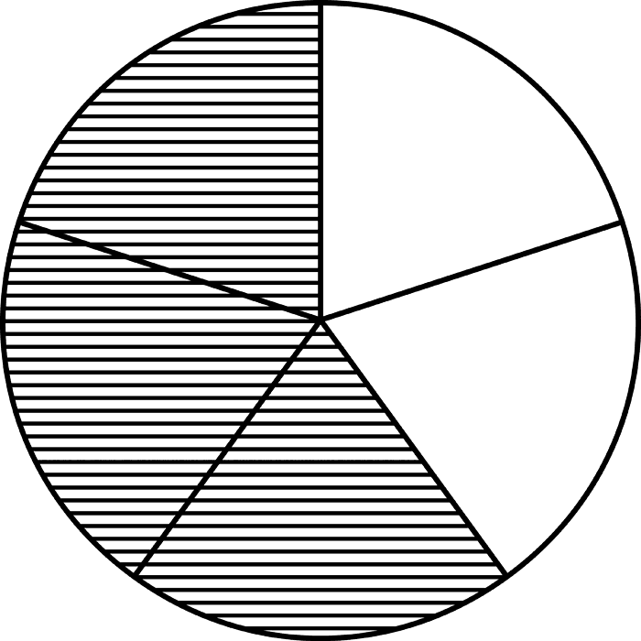 3  Denominator 5
Difference | The answer to a subtraction problem. | 10 - 7 = 3  Difference
Digits | The symbols used to write numbers. | 0, 1, 2, 3, 4, 5, 6, 7, 8, 9
Dime | US coin worth 10 cents. | 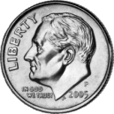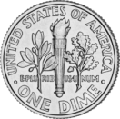
Dividend | The number to be divided (shared). | 21 ÷ 7 = 3  Dividend
Divisor | The number by which another number is divided. | 21 ÷ 7 = 3  Divisor
Edge | A line segment where 2 faces of a solid meet. | edge
Face | A flat surface of a solid that does not roll. | face
Factors | Numbers that are multiplied together to give a product. | 3 x 5 = 15  factors
Median | The number in the middle of a list of numbers ordered least to greatest. | 1, 1, 2, 4, 5, 7, 7  median: 4
Mode | The number that is most often used in a list of numbers. | 1, 2, 3, 3, 4, 5, 5, 5, 6, 11  mode: 5
Multiple | The product of the number and any other whole number. | Multiples of 8:  8, 16, 24, 32, 40, 48, 56, 64, 72, 80, ..
Nickel | US coin worth 5 cents. | 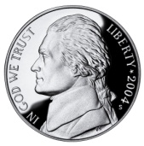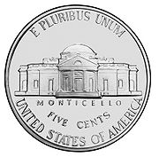
Numerator | The number above the fraction bar in a fraction. | Numerator 3  5
Obtuse Angles | An angle that measures greater than a right angle.  An angle that measures greater than 90°.
Penny | US coin worth 1 cent. | 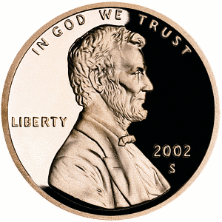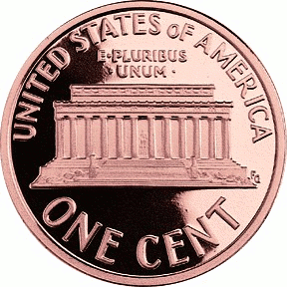
Perimeter | The distance around a figure.  l + l + h + h = perimeter  5 + 5 + 2 + 2 = 14  or  2 length + 2 height = perimeter  (2 x 5) + (2 x 2) = 14
Polygon | A shape that has straight lines and is a closed figure.
Product | The answer to a multiplication problem. | 3 x 5 = 15  product
Quarter | US coin worth 25 cents. | 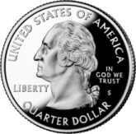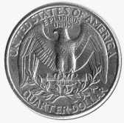
Quotient | The answer to a division problem. | 21 ÷ 7 = 3  Quotient
Range | The difference between the greatest and the smallest numbers in a list. | 2, 5, 5, 10, 12, 13, 16  16 - 2 = 14  Range
Right Angle | An angle that forms a square corner.  An angle that measures 90°.
Sum | The answer to an addition problem. | 21 + 7 = 28  Sum
Vertex  Vertices (plural) | The point where the edges of a solid figure meet.  The point where the edges of a polygon meet. | vertex
Volume | The number of cubic units needed to fill a solid figure.  length x width x height = volume  1 x 2 x 2 = 4

